GIT AND GITHUB-TASK
=========================================
- Install git.
- Installing Git Bash automatically installs Git on your system
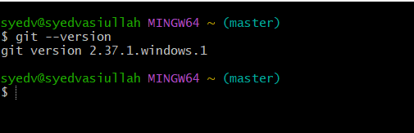

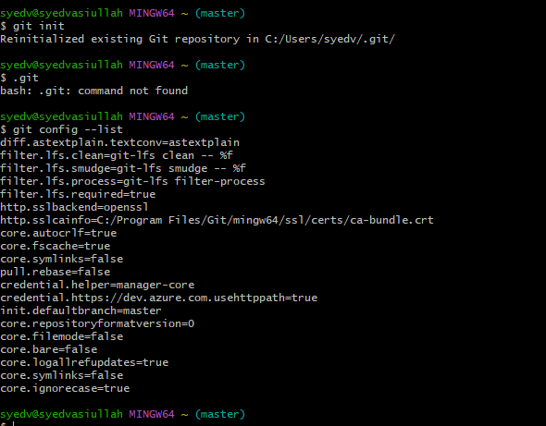
- Create a repo in github with README.md and .ignore file.
- README.md = A file to describe your project (like a title page in a notebook).
- gitignore = A file to tell Git which files NOT to track (like hiding your secrets).

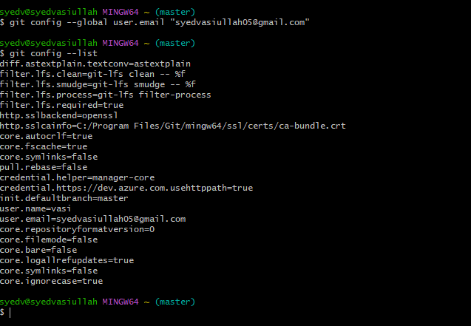
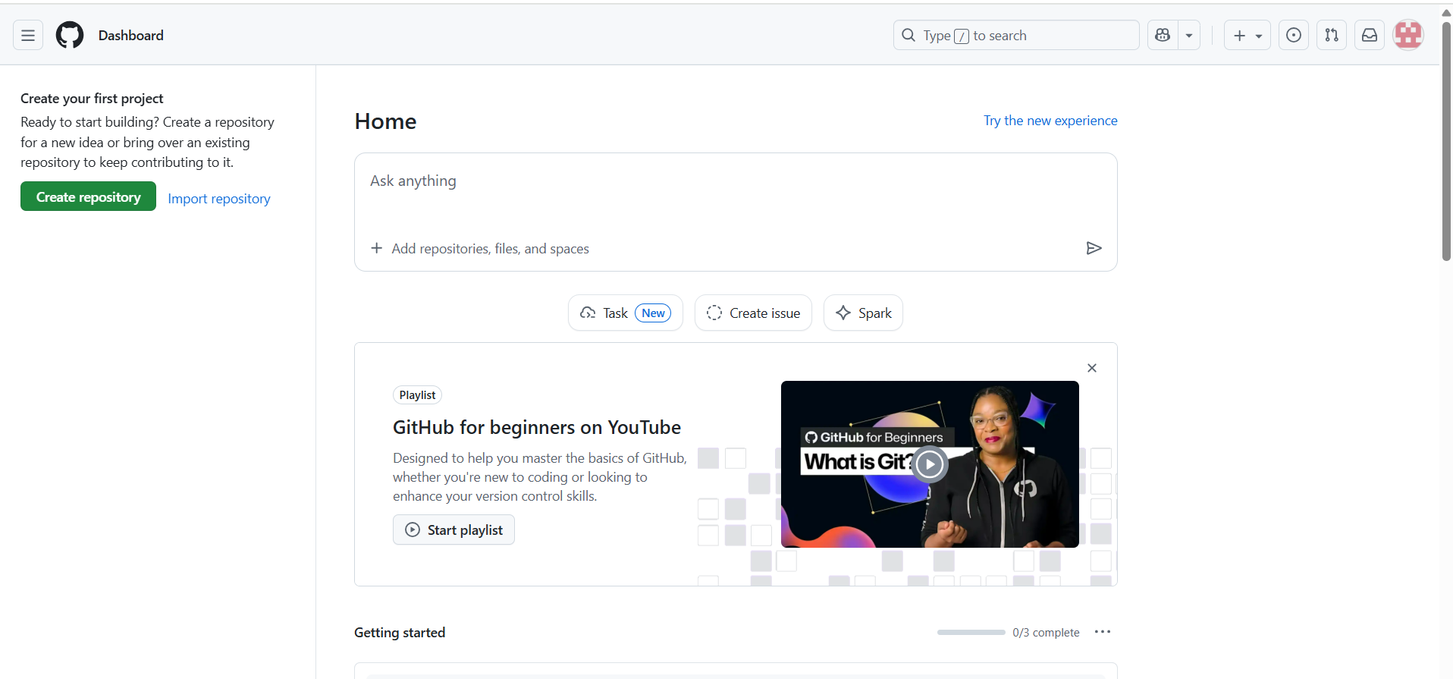
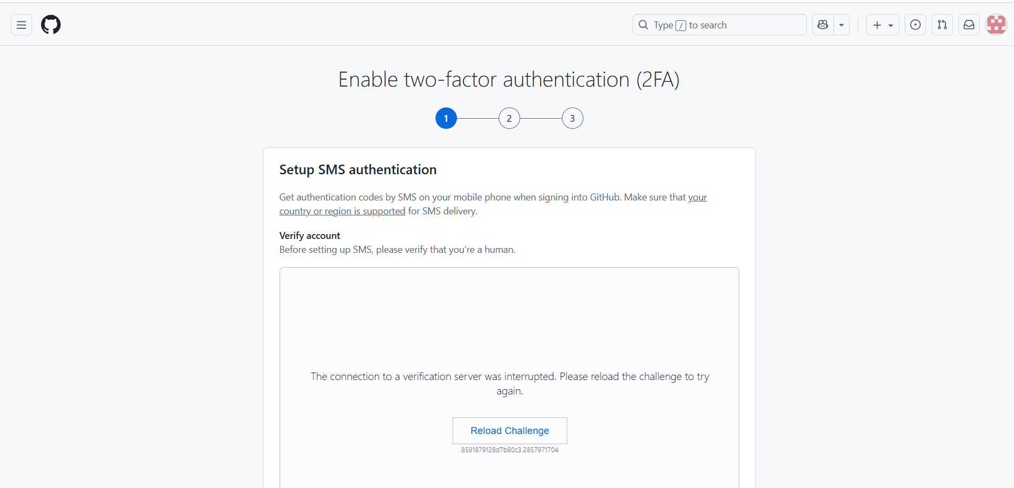
- Clone the created repo to local.
- GitHub SSH KEY

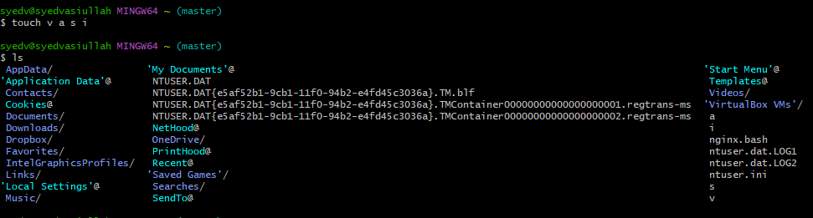
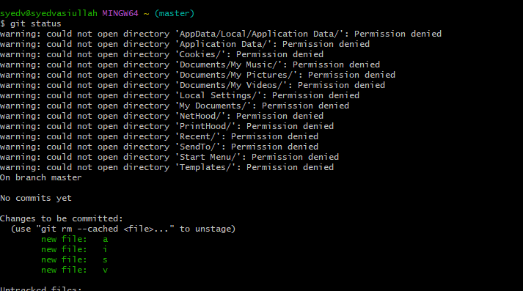
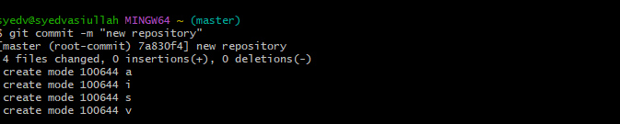
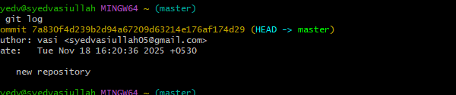
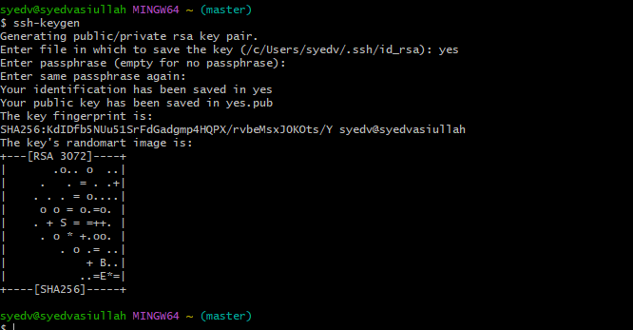
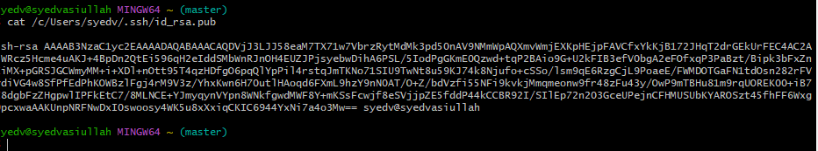
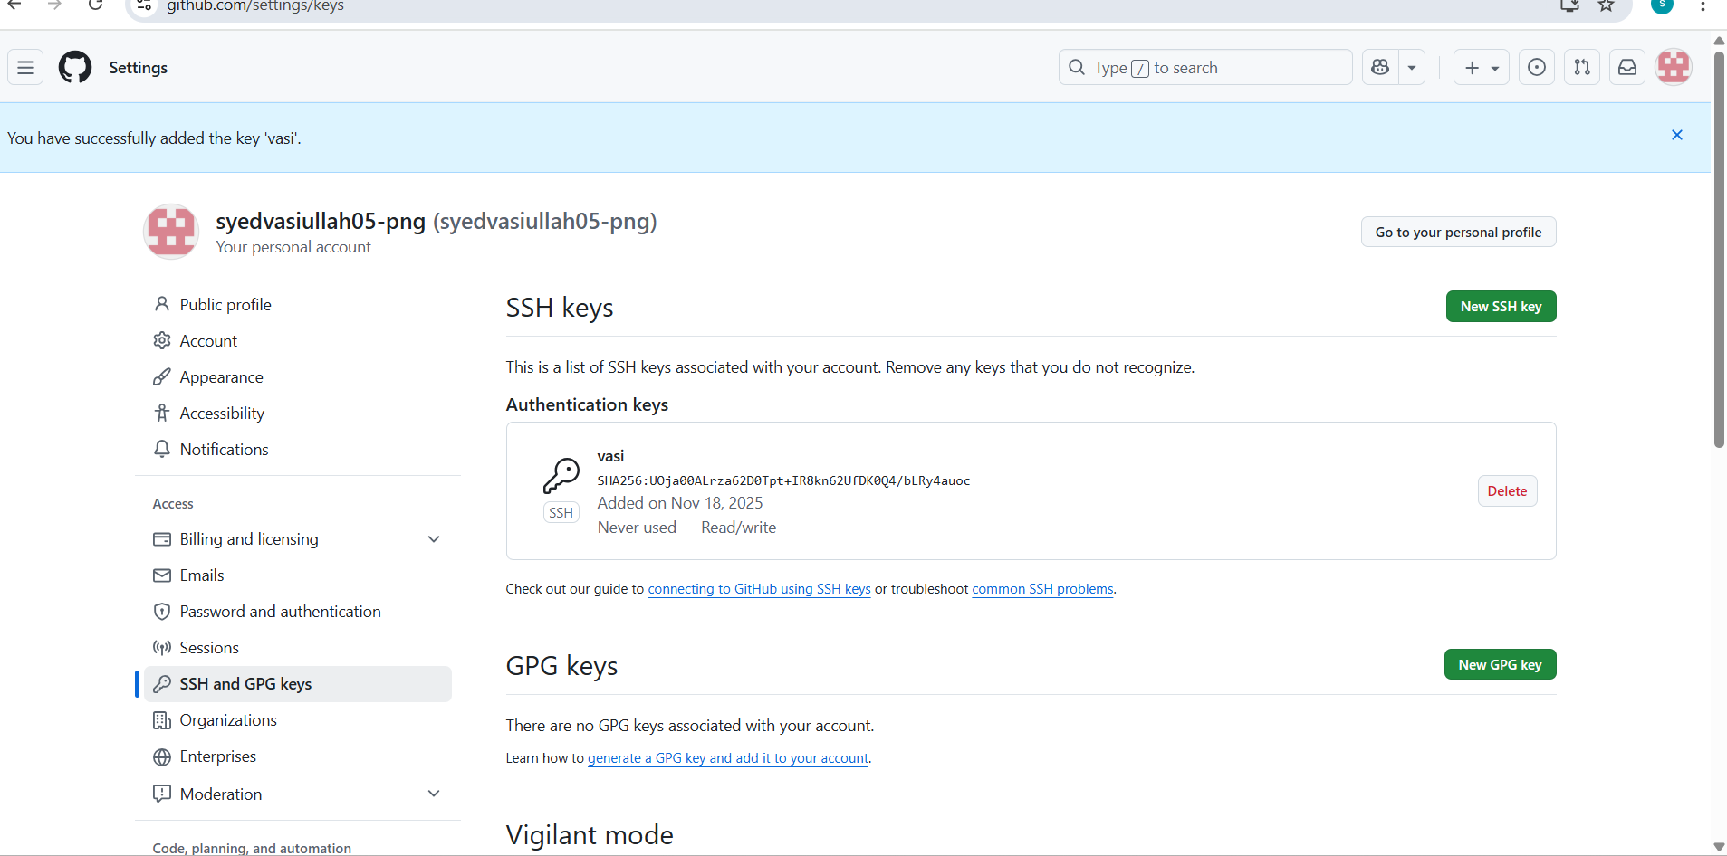
- Create two files in local repo.
- Files can be created using commands like touch or text editors.
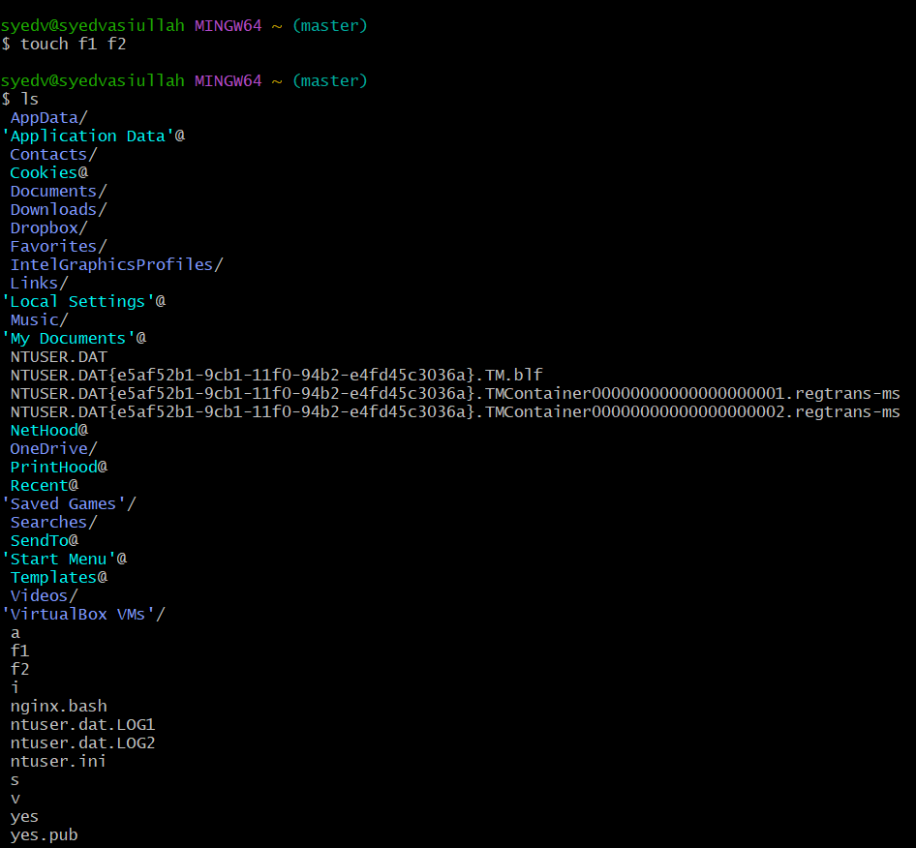

5.Commit two files and push to central Repository
- touch → make new files.
- git status → check which files Git sees.
- git add . → tell Git to track the files.
- git commit -m "message" → save changes locally.
- git push origin master → send changes to GitHub.

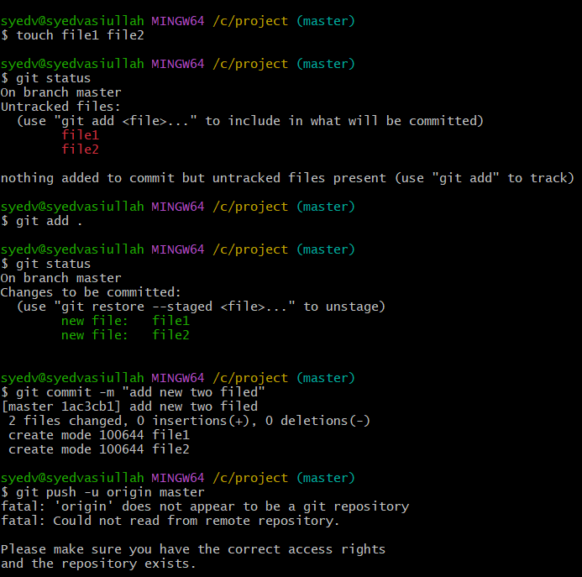
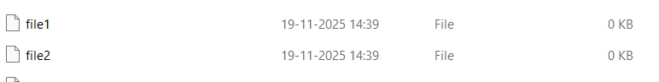

- After this, both files appear in your GitHub repository.

6.Create a branch in local and create a sample file and push to central.
- git checkout -b new-branch = Make a new path to work without disturbing main
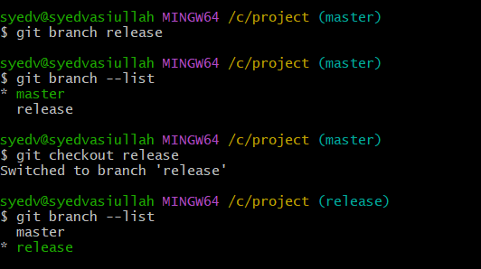
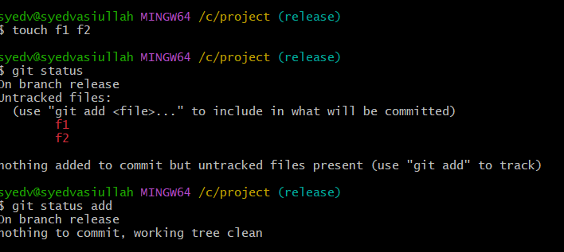
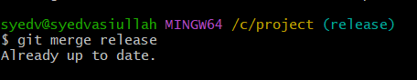


7.Create a branch in github and clone that to local.

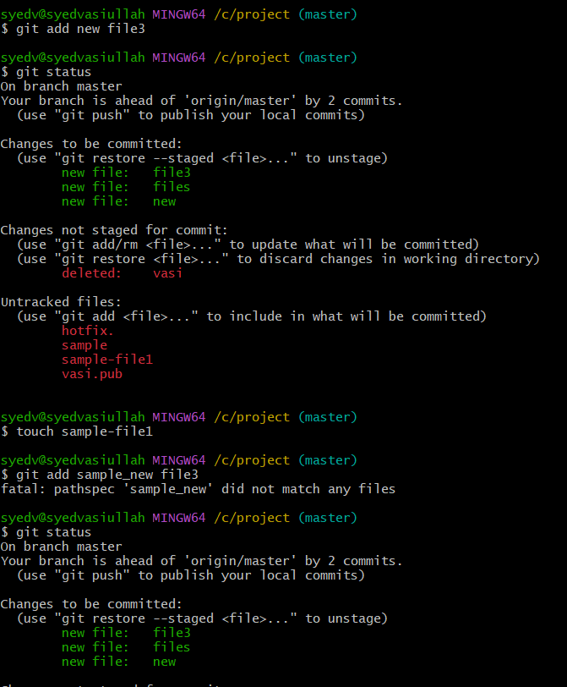
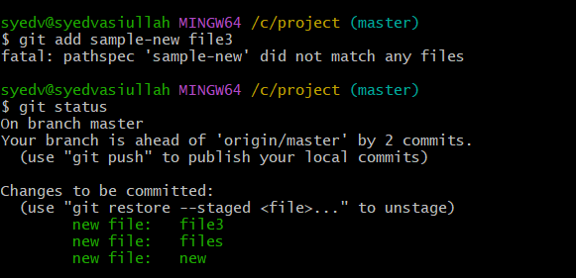
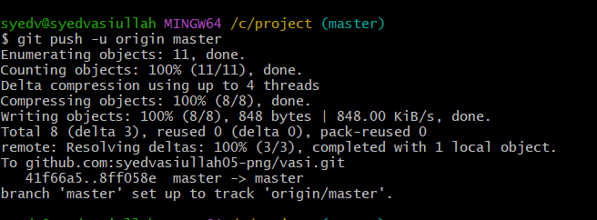


8.Merge the created branch with master in git local.
- You successfully created a new branch (mariya)
- You confirmed it exists with git branch –list
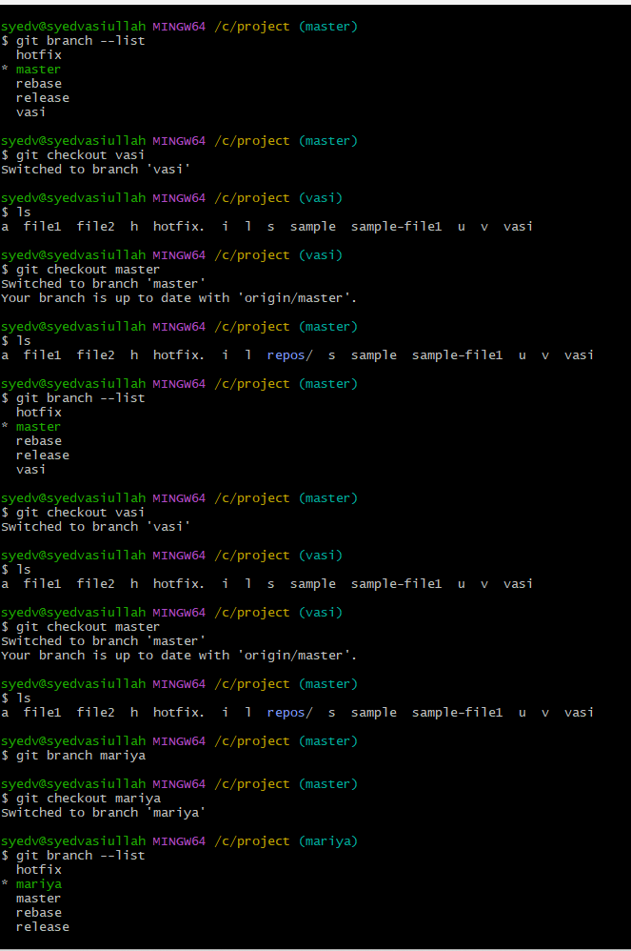

9.Merge the created branch with master in github by sending a pull request.
- Your branch master in GitHub through a push request.
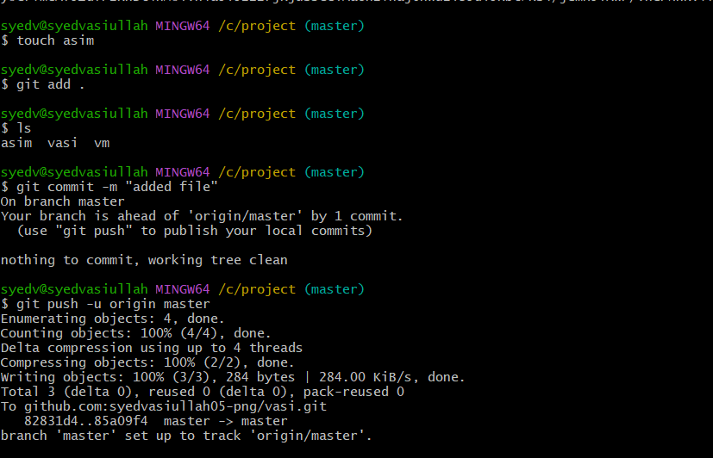
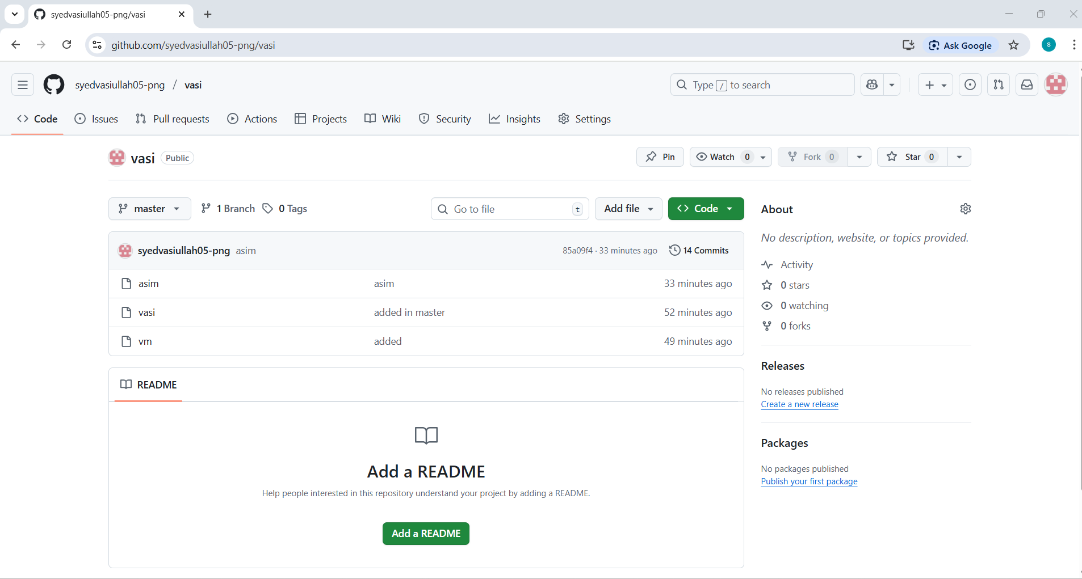

10. Create a file in local and send that to branch in github
- File created locally
File added to Git
File committed
File pushed to master branch in GitHub
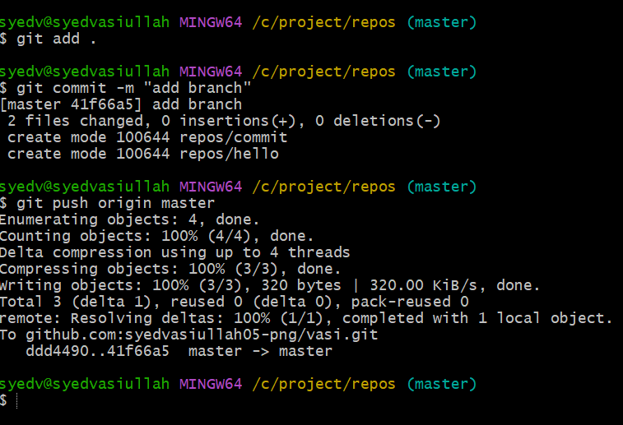
11Clone only a branch from github to local.
- The command the user is running is: $ git clone -b master git@github.com:syedvasiullah05-png/new-files.git

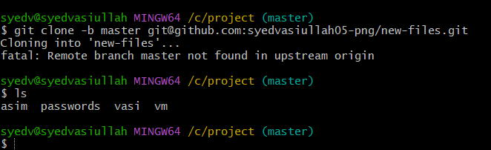
12.Create a file with all passwords and make that untrackable with git.

- passwords.txt stays safely only on your computer
- Git does not track it
- It will not push to GitHub
- It remains completely untrackable by Git

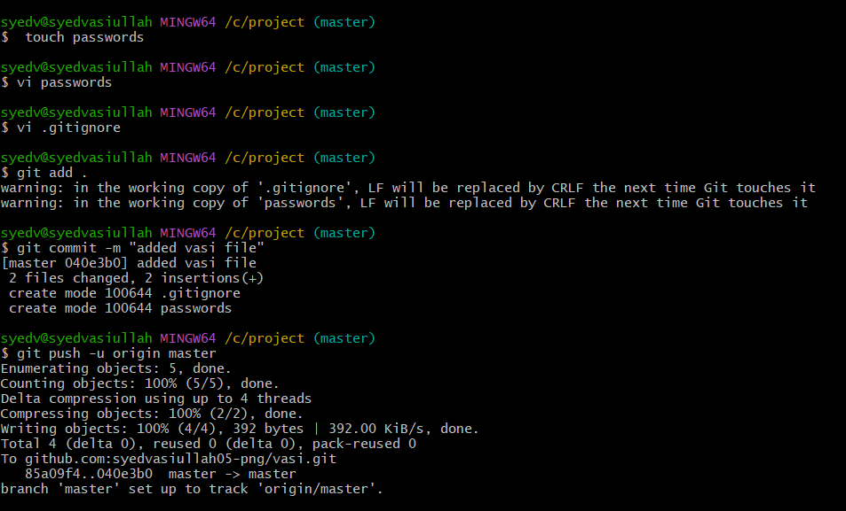

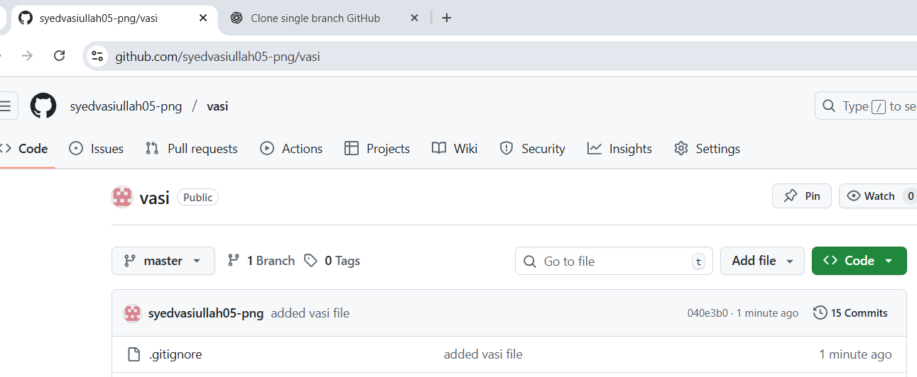
13.Make a commit and make that commit reset without savings changes.
git add . → stages all modified files
git commit -m "my commit" → creates a new commit with the message "my commit"
git reset --soft HEAD~1
--soft → removes only the commit, not the changes
git log –oneline

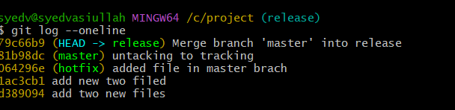

14.Revert a commited commit to the older version.
- Shows the history of commits in your Git repository.
- Change the commit message
- Add new changes to the last commit
- Revert,→ safe, creates a new commit that undoes changes.
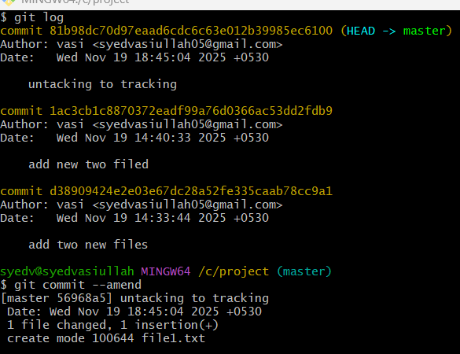
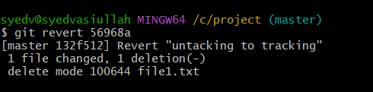

15.Push a file to stash without savings the changes and work on another file.
- one file, use git add . filename instead.
- git stash list = See your stashes
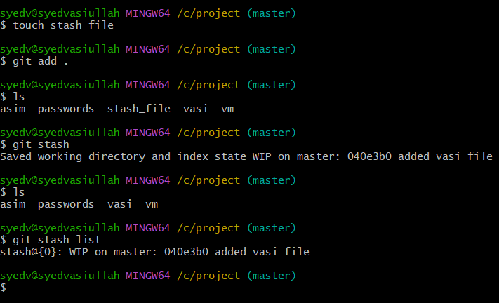
16.Undo the stash file and start working on that again.
- git stash pop = Restore changes and remove from stash
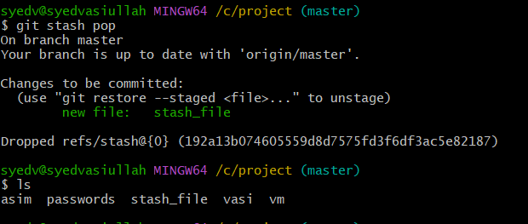
17.Generate a ssh-keygen and configure into github.
- Go to GitHub → Settings → SSH and GPG keys → New SSH key.
- Paste your copied key.
- Give it a name like “My Laptop” and click Add SSH key.

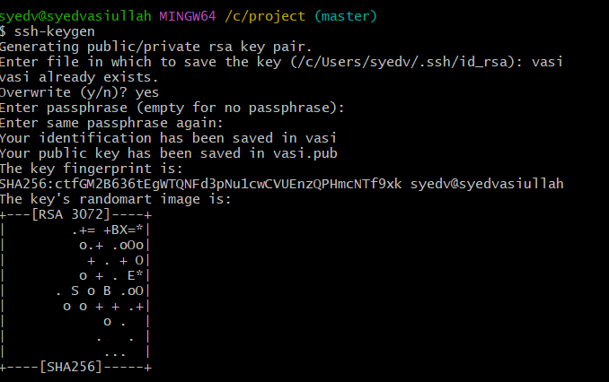
18.Configure webhooks to github.

19.Basic understanding of .git file.
- .git is a hidden folder that Git creates inside your project.
- It stores all commit history, branches, and changes of your project.
- Even if you delete or change files, .git keeps old versions safe.
- Without .git, your folder becomes a normal folder (not a Git repo).

20.Check all the logs of git.

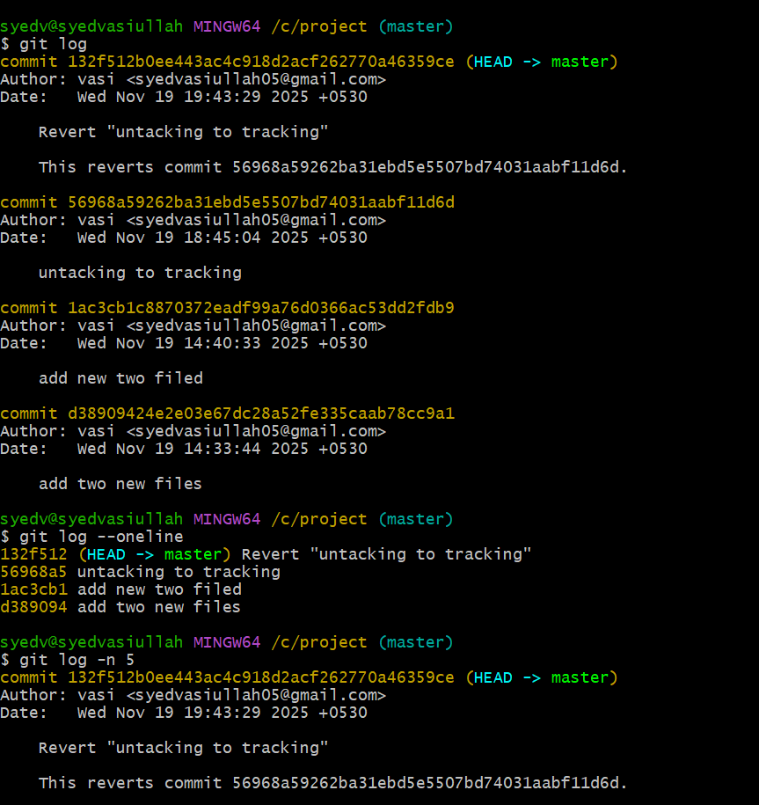

21.Rename the commit message.
- View the commit history the git log command
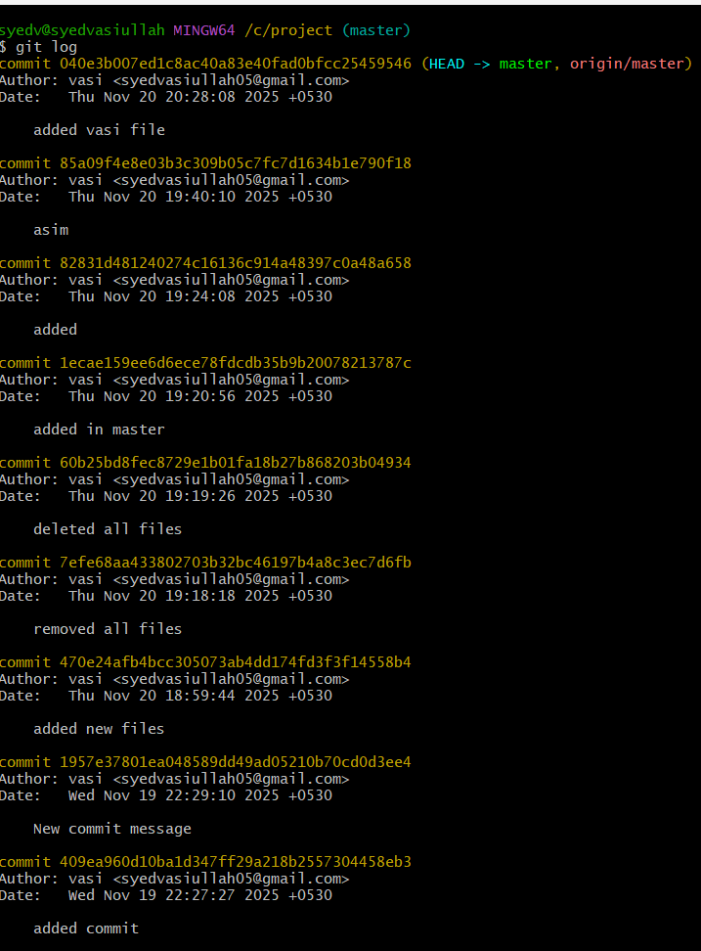

- git commit --amend edits the last commit without creating a new one
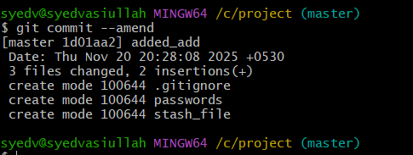

22.Merge multiple commits into single commit.
- git rebase -i HEAD~N
- Mark commits to squash:
- Keep pick for the first commit.
- Change pick → squash for others.
- Edit commit message:
- Combine messages into a single commit message.
- Finish rebase:
- Save and close the editor.
